Dept. of Zoology
Nalbari College, Nalbari
Assam, Pin-781335

- Title of event: A FIELD VISIT TO GARBHANGA RESERVE FOREST
- Venue: GARBHANGA RESERVE FOREST
- Date: 14.09.2022
- Organized by: DEPT. OF ZOOLOGY, NALBARI COLLEGE, NALBARI
- Faculty Coordinators: KUMUD CH. RABHA & BIDYUT KR. DAS
- No. of Participants: 33
- Detail Description of the event:
A Field visit to Garbhanga Reserve forest of B.Sc IVth Sem Honours Students is a requirement for partial fulfillment of the syllabus. Garbhanga Reserve Fores is a wildlife sanctuary on the southwestern side of Guwahati City, bordering the state of Meghalaya, India. The forested area is the key urban wildlife site and catchment area near Guwahati City. Located approximately 15 km (10 miles) away from Guwahati, Garbhanga Wildlife Sanctuary is situated in the southern part of Assam, bordering the foothills of Meghalaya. It is located very close to the Deepor Bill, and because of its location in an urban area it is considered a key wildlife area of Guwahati City. Garbhanga Wildlife Sanctuary has a total land area of 117 km² and lies between the Garbhanga and Rani ranges. A total of 33 students of B.Sc IVth Sem Honours Students participated in this field visit. A diversity of butterflies, birds etc. are observed during the visit.

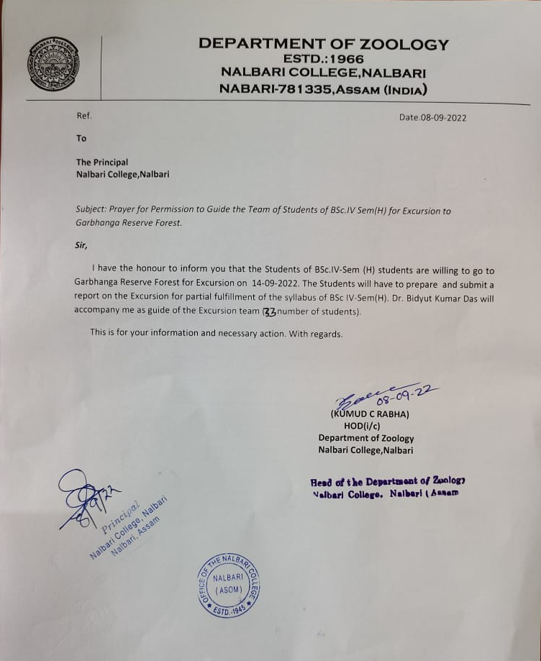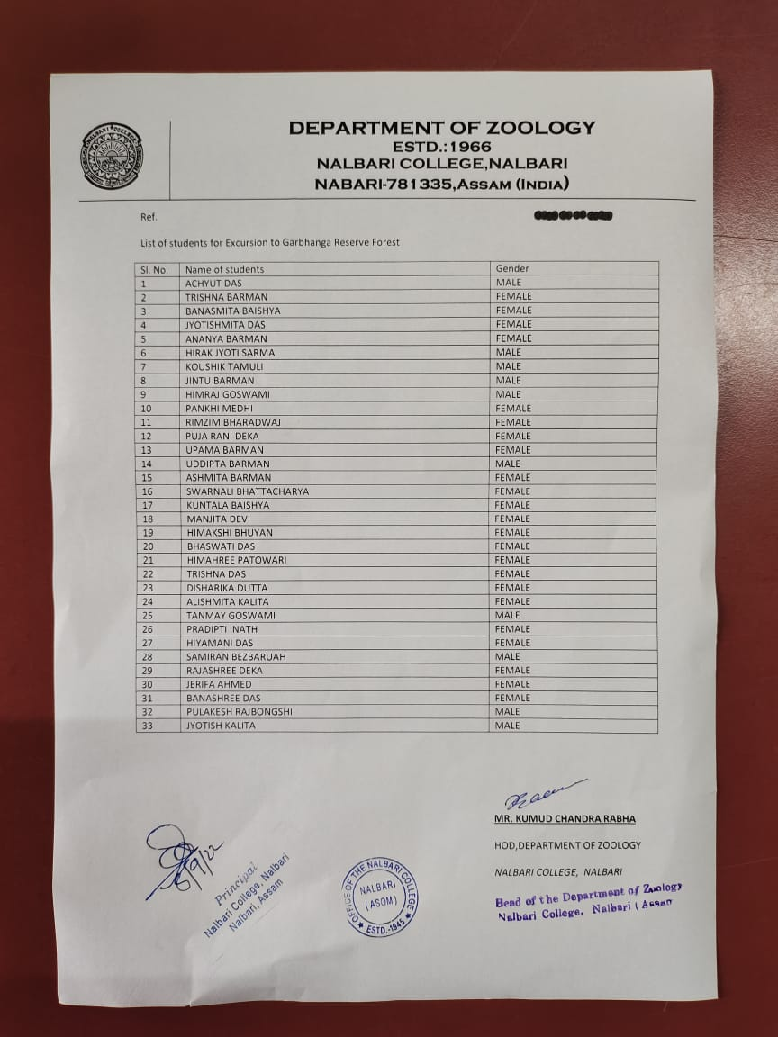
Application forwarded by the principal for the permission to visit the Garbhanga Reserve Forest

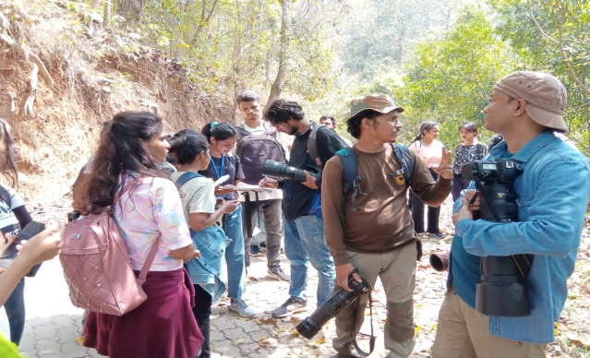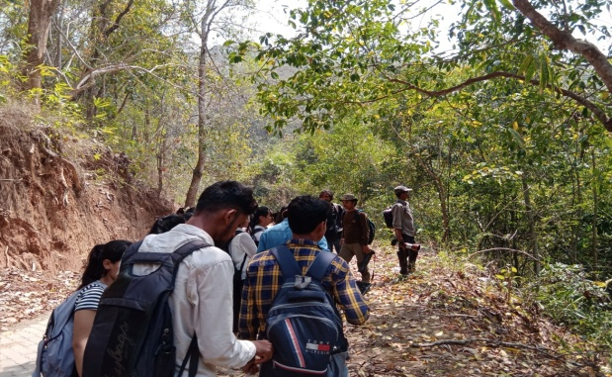
Photographs of students and teachers during the field visit

