Visited IASST (Institute of Advanced Study in Science and Technology) An Autonomous Institute under Department of Science & Technology, Govt. of India situated at Boragaon, Ghy-35 on the occasion of “Open Day Celebration” on 9th March, 2019. Students interaction with different research scholars and laboratory visit definitely arises the spirit of doing science and looking science from different prospective. B.Sc 6th Sem Zoology Honours students, Nalbari Collge, Nalbari visited IASST along with guide teachers Dr. Meetali Deori and Dr. Purabi Sarmah.
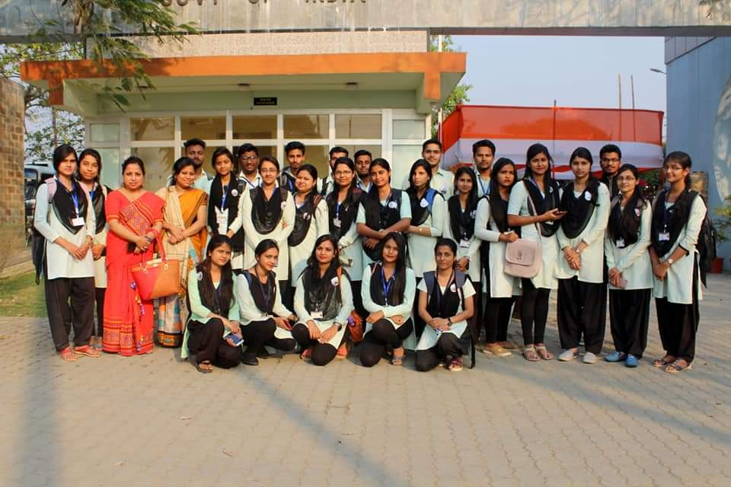
Group photo of students and guide teachers in the entrance of IASST gate

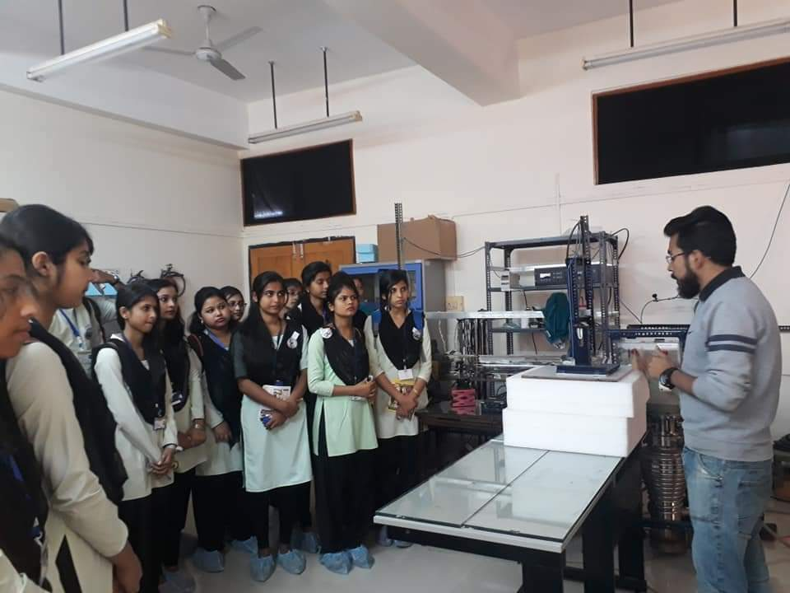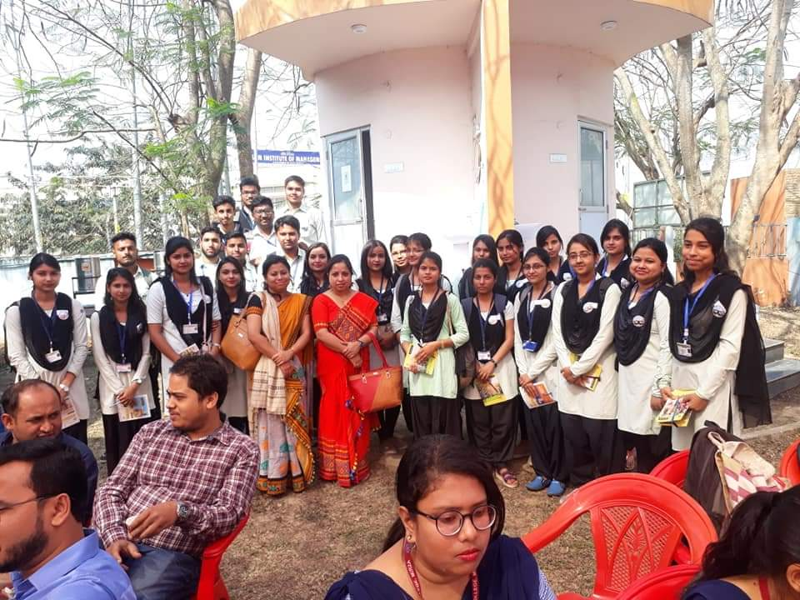
Interaction of students with research scholars of IASST

