- Title of the event: A one day Workshop on “How to clear bank exams: tips & strategies for success”.
- Venue: Conference hall, Nalbari College, Nalbari
- Date: 28/09/2024
- Organized by: Department of STATISTICS, Nalbari College, Nalbari

- Faculty Coordinator: Manash Kalita, Central Bank, Mushalpur

- No of Participants in details (students): 94

- Nature of Participation: Students

- Activities Carried out / Detail Description of the event:

The Workshop started with the inauguration programme at 11:05 am where HOD of the department of Statistics Dr. Bhupen Kr. Nath, teachers of our Department and students of different discipline were present. The programme continued with a small felicitation to the resource person by the student of the department. Later on, Manash Kalita, who is also an ex-student of our department, took the platform. He talked about various topics related to bank like; types of banks, types of exams, types of questions, allowances, salary, etc. All the students and teachers present in the workshop participated actively in the workshop. The students reported that the session were highly satisfactory which will help them in their future endeavours. All the students present in the session were tea and biscuit.
- Photographs (Maximum 5 GeoTag photographs for offline programme or screenshot for online programme including the Banner):

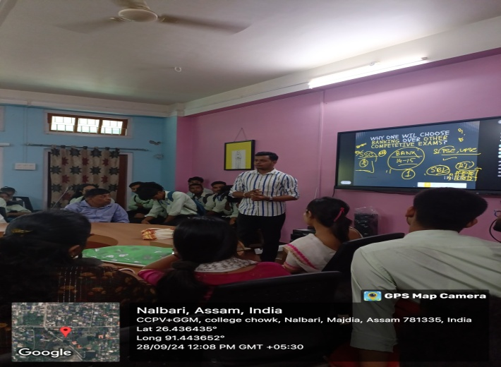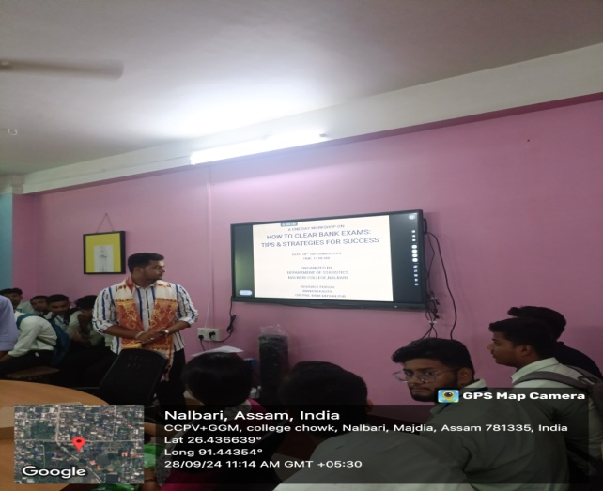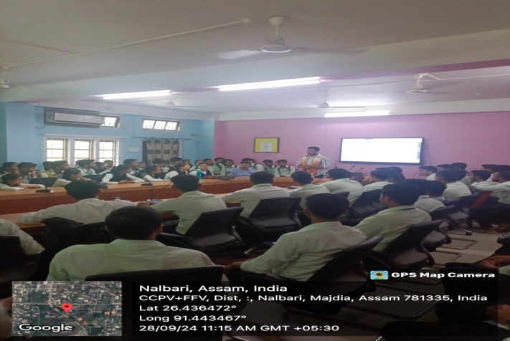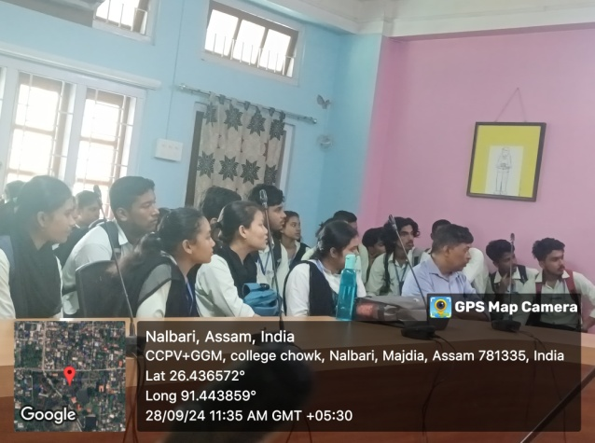

- Signature of participants:
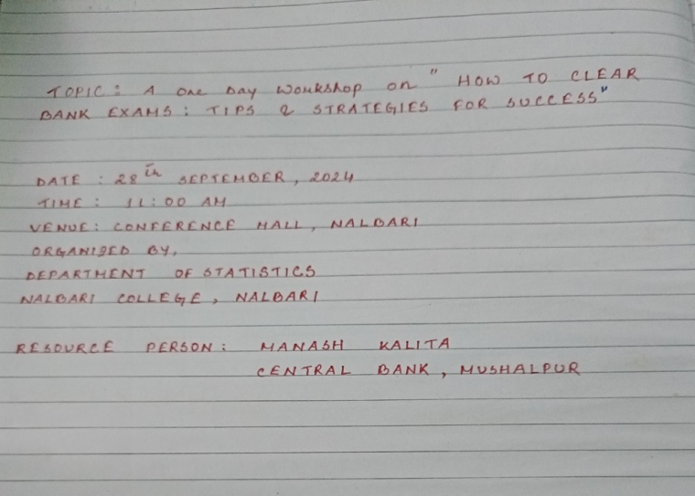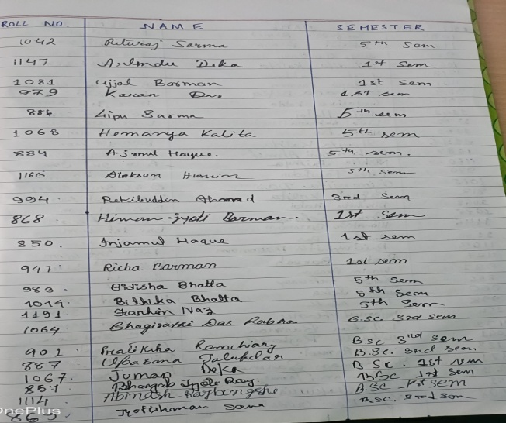
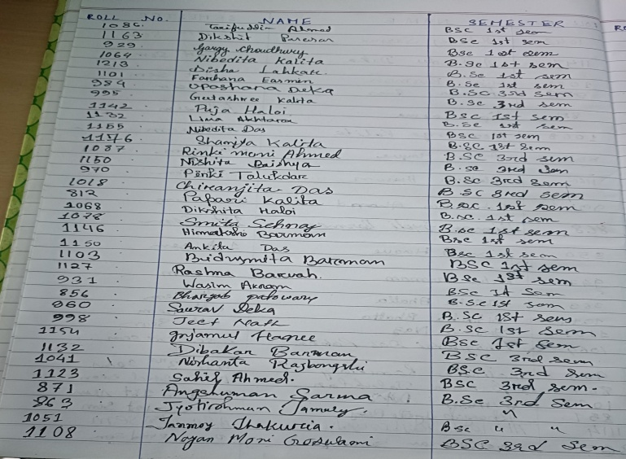

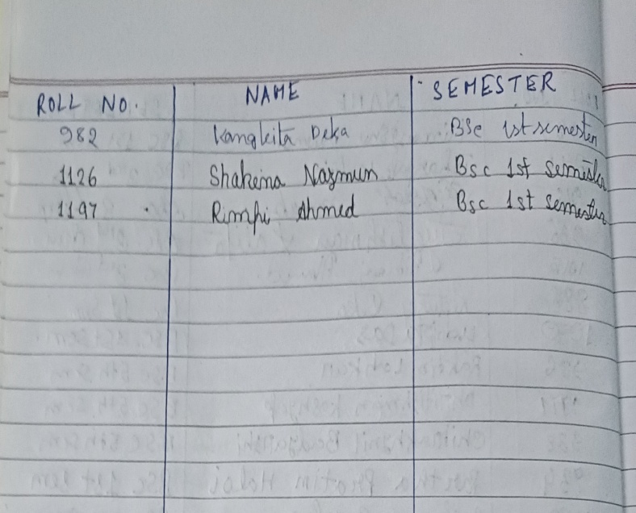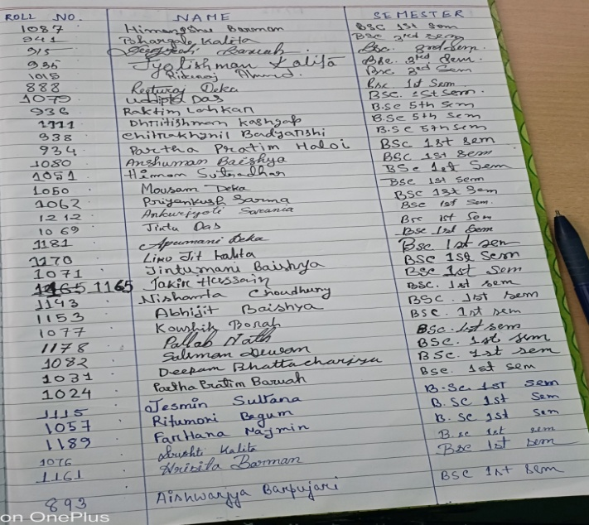

- Feedback on the programme from the participants/guest (if any):

