- Title of the event: Educational Tour
- Venue: AAU- Horticulture Research Station, Kahikuchi, Azara, Guwahati.
- Date: 5th December, 2024
- Organized by: Jointly organized by Department of Statistics, Nalbari College, Nalbari & Department of Statistics, Pub-Kamrup College, Kamrup
- Faculty Coordinator: Dr. Bhupen Kr. Nath, from Department of Statistics, Nalbari College &
Dr. Nilima Dutta, from Department of Statistics, Pub-Kamrup College

No of Participants in details (students): 23(From Nalbari College) & 15 (From Pub-Kamrup College)
- Nature of Participation: Field Study by Teachers & Students.

Activities Carried out/Detail Description of the event:
An Educational Tour was jointly conducted at AAU- Horticulture Research Station, Kahikuchi, Azara, Guwahati by Department of Statistics, Nalbari College, Nalbari & Department of Statistics, Pub-Kamrup College, Kamrup. The field study was conducted to gather information about basics of Design of Experiments. An experimental layout of RBD was shown to the students and teachers with the help of Brinjal cultivation.

- Photographs:
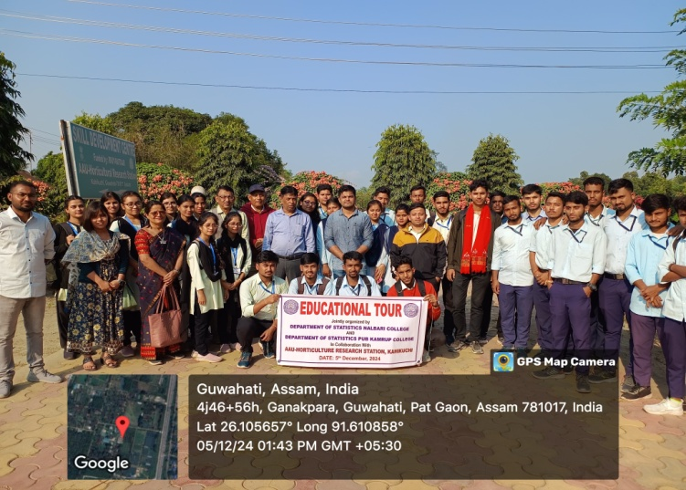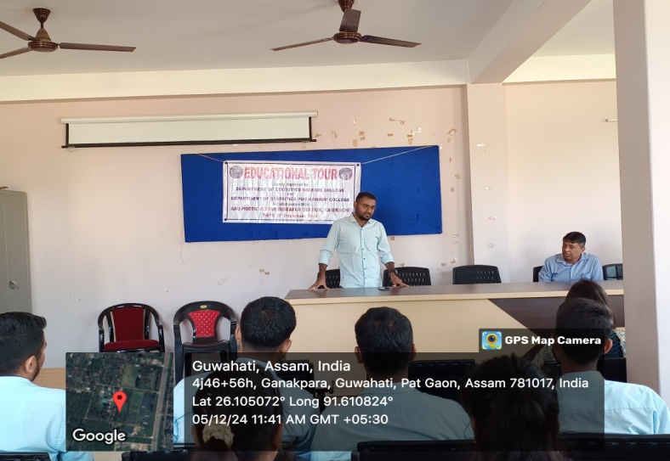

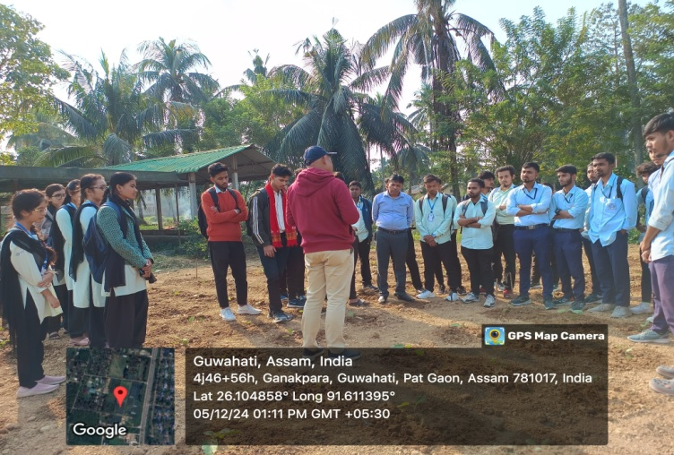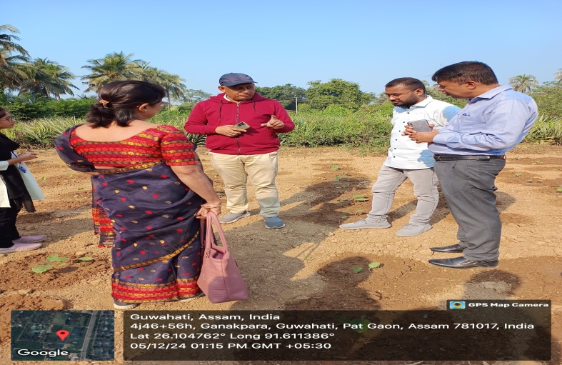
- List of Students (From Nalbari College):

Serial Number | Roll Number | Name of the Student | Semester
1 | 918 | Mrinal dutta | 3rd Semester
2 | 935 | Jyotishman Kalita | 3rd Semester
3 | 941 | Bhargab Kalita | 3rd Semester
4 | 963 | Bhargab Jyoti Deka | 3rd Semester
5 | 966 | Papori Deka | 3rd Semester
6 | 970 | Pinki Talukdar | 3rd Semester
7 | 984 | Upasana Deka | 3rd Semester
8 | 994 | Rekibuddin Ahmed | 3rd Semester
9 | 1067 | Bipasha Thakuria | 3rd Semester
10 | 1102 | Nishita Talukdar | 3rd Semester
11 | 1108 | Nayan Moni Goswami | 3rd Semester
12 | 1153 | Mrinmoy Sarma | 3rd Semester
13 | 884 | Ajmul Haque | 5th Semester
14 | 886 | Lipu Sarma | 5th Semester
15 | 936 | Raktim Lahkar | 5th Semester
16 | 938 | Chitrakhya Nil Badyarishi | 5th Semester
17 | 983 | Bidisha Bhatta | 5th Semester
18 | 1014 | Bithika Bhatta | 5th Semester
19 | 1042 | Rituraaj Sarma | 5th Semester
20 | 1068 | Hemanga Kalita | 5th Semester
21 | 1111 | Dhritishman Kashyap | 5th Semester
22 | 1166 | Aleksun Hussain | 5th Semester
23 | 1191 | Farhin Naz | 5th Semester

