- Title of the event: A one day Seminar on “Essential Skills and Career Readiness for Corporate Sector Jobs”
- Venue: Conference hall, Nalbari College, Nalbari
- Date: 29/03/2025
- Organized by: Department of STATISTICS, Nalbari College, Nalbari

- Resource Person(s): Kritartha Pratim Deka,
Deputy Manager, Reliance Jio
Mrinmay Jyoti Deka
Junior Assistant in Secondary Education, Govt. of Assam

- No of Participants in details (students): 64

- Nature of Participation: Students

- Activities Carried out / Detail Description of the event:

The Seminar started with the inauguration programme at 10:40 am where HOD of the department of Statistics Dr. Bhupen Kr. Nath, teachers of our Department and students of different discipline were present. The programme continued with a small felicitation to the resource persons by the students of the department. Later on, Mrinmay Jyoti Deka, who is also an ex-student of our department, took the platform. He talked about the present job market in various government as well as private sector organization. He gave a presentation regarding how there is an absolute scarcity of government jobs as day by day job aspirants are increasing but government sector jobs are limited. He came up with a solution to overcome this problem by applying in various MNC’s not only in India but also all over the world. Subsequently, the other resource person Kritartha Pratim Deka took the platform and spoke about various skills required to get into these MNC’s. All the students and teachers present in the seminar participated actively. The students reported that the session were highly satisfactory which will help them in their future endeavours. All the students present in the session were provided with tea and biscuit.
- Photographs :

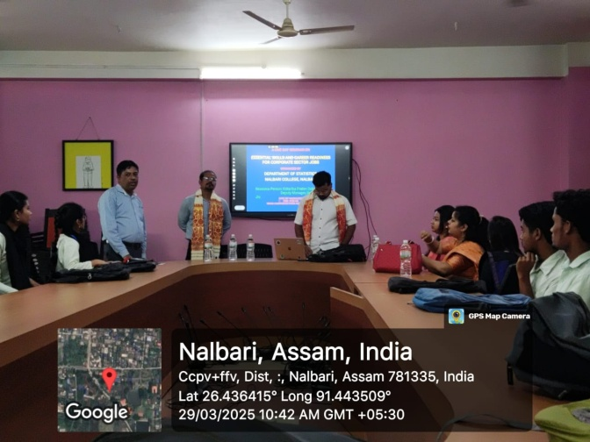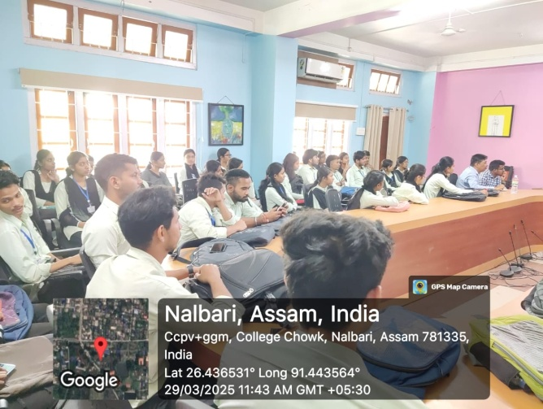

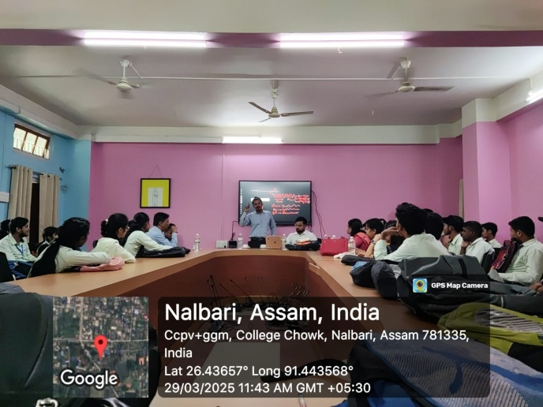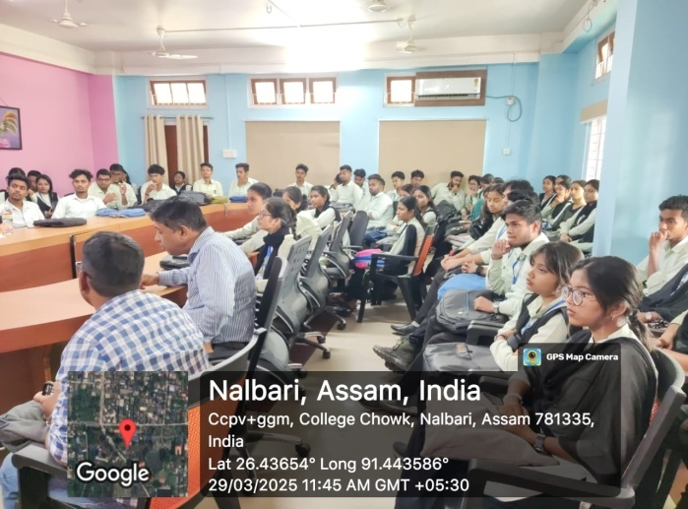

- Signature of participants:

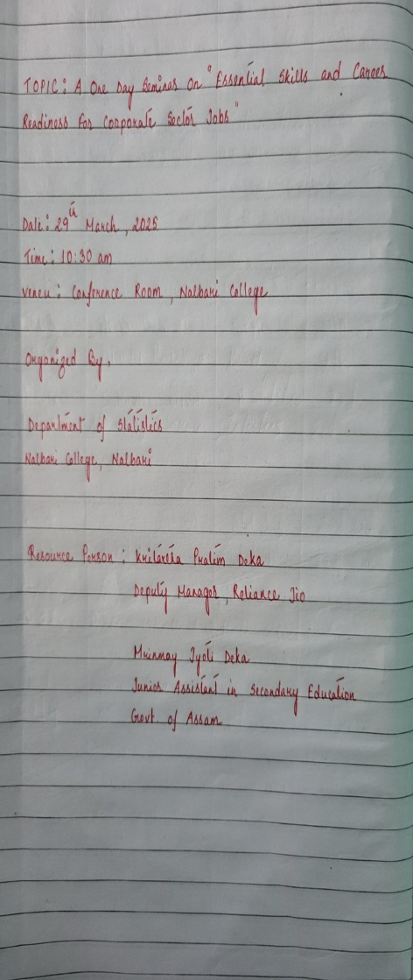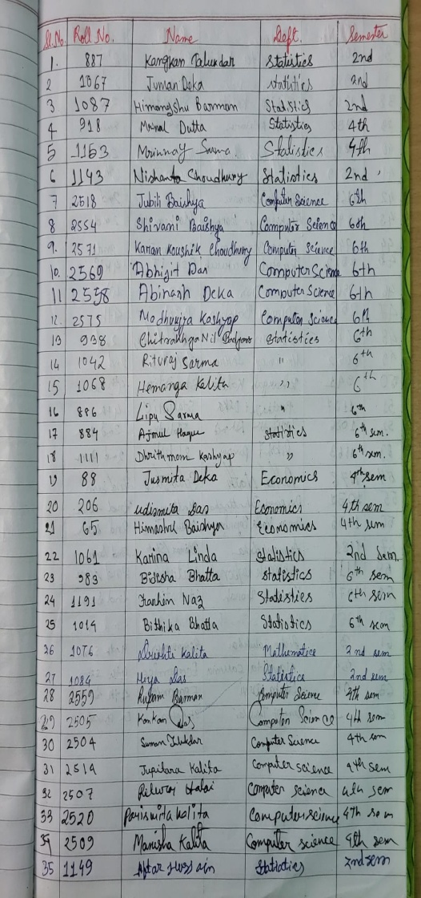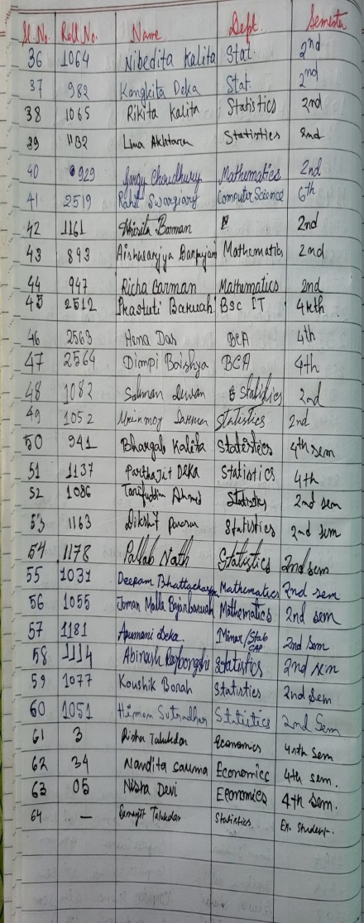

- Feedback on the programme from the participants/guest (if any):

