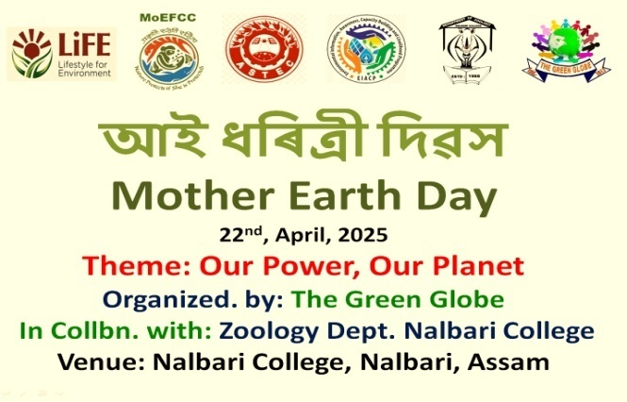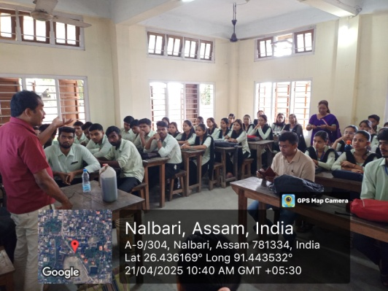
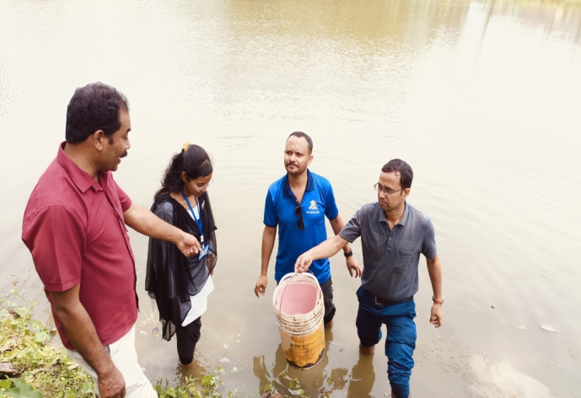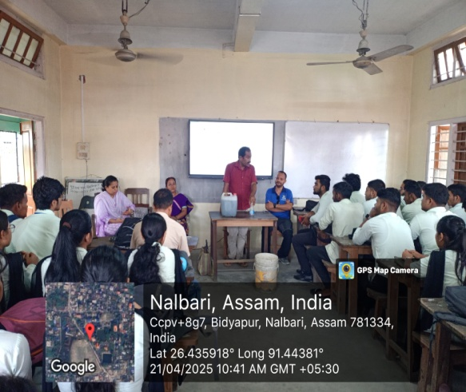
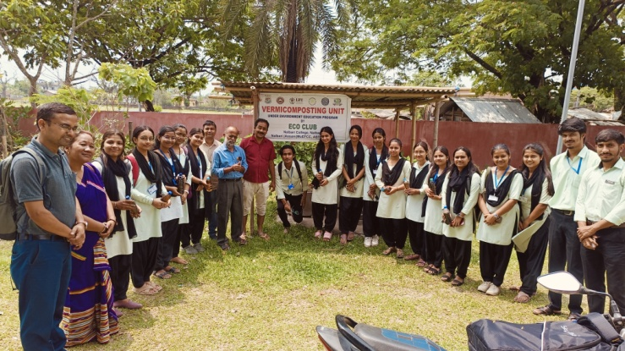
Zoology Department of Nalbari College celebrated Mother Earth Day on 22nd April with
The Theme: Our Power, Our Planet organized by: The Green Globe In collaboration with Zoology Dept. Nalbari College. Many students of Zoology Department participated in the programme. Kumud Chandra Rabha, HoD, Zoology Department delivered a speech on the importance of Mother Earth Day and discuss the different challenges and its preventive measures. Rajesh Dutta Baruah, the Secretary of Green Globe delivered a speech emphasizing on the theme.

