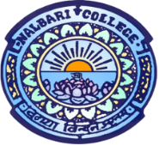
Department of Political Science
Nalbari College, Nalbari
Assam, Pin: 781335
_______________________________________________________
1. Title of the event: “A Talk on Human Rights” on the occasion of International Human Rights Day, 10th December.
2. Venue: Nalbari College, Nalbari (Room No. 8)
3. Date: 10th December, 2025 (Wednesday)
4. Organized by: Department of Political Science and IQAC, Nalbari College, Nalbari
5. Faculty Coordinator: Dr. Rahul Daimary, HOD, Political Science
IQAC, Coordinator: Dr. Hangshadhar Rajbongshi, Deptt. Of Physics
6. No. of Participants in details (students): 21 (Total 30 with Teaching Faculties)
7. Nature of Participation: Interaction between Resource person and Students through offline mode.
8. Activities Carried out/Detail Description of the event: Resource Person: Dr. Binoy Musahary, Assistant Professor, Department of Political Science, Nalbari College, Nalbari.
Theme: Basic Concepts of Human Rights
9. Program Sheet: Time: 10.30 AM (10-12-2025)
- Acceptance of Chair and felicitation to guests:
- Inauguration of the Program: Dr. Kamal Nayan Patowary, Principal, Nalbari College, Nalbari
- Explanation of Objective of the Event: Kaberi Dutta, Assistant Professor, Deptt. Of Political Science, Nalbari College, Nalbari
- Technical Session-Resource Person: Dr. Binoy Musahary, Asstt. Prof., Department of Political Science, Nalbari College, Nalbari
- Theme: Basic Concepts of Human Rights
- Tea Break:
- Vote of Thanks: Kaberi Dutta, Asstt. Prof., Department of Political Science, Nalbari College, Nalbari

----End of the Program----

9. Photographs of the Event:

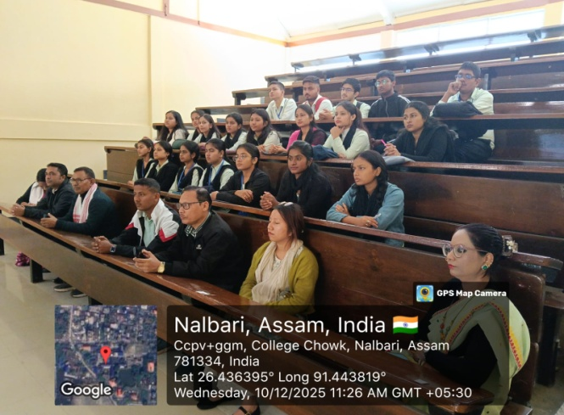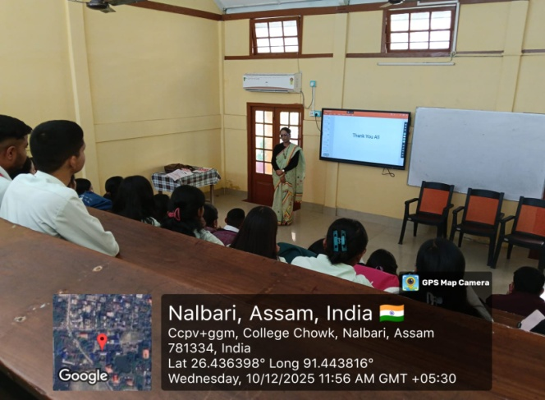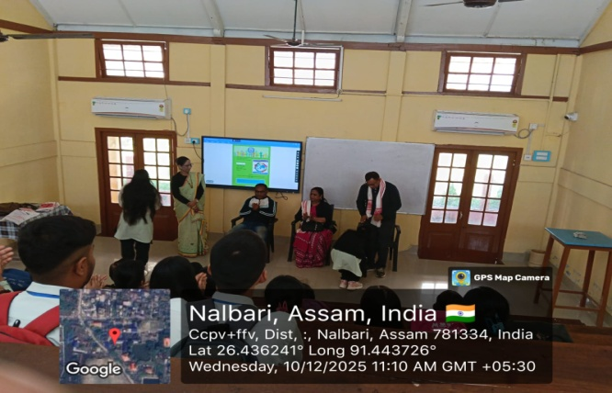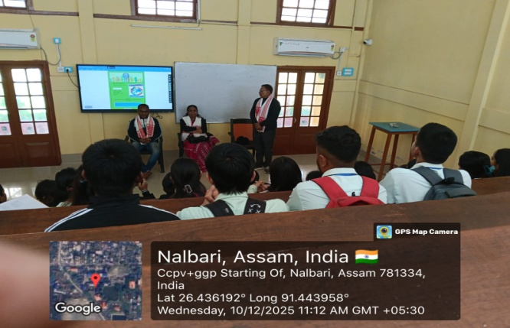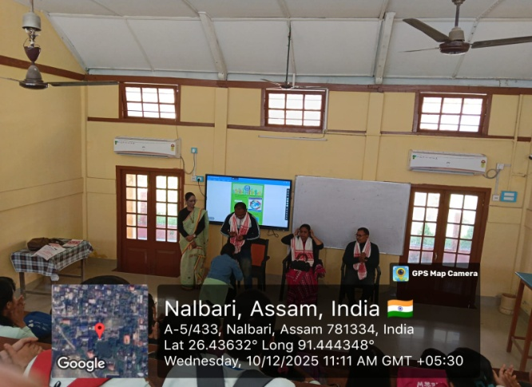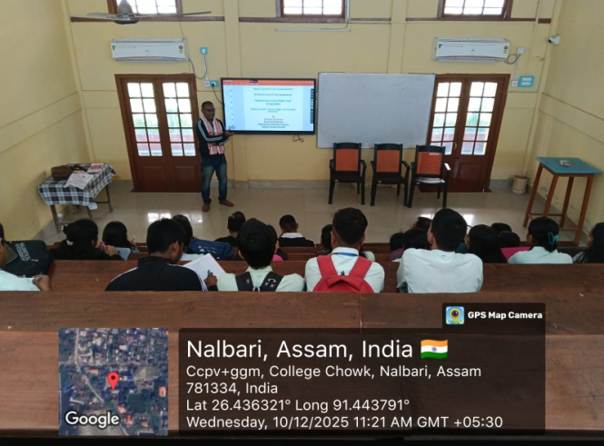

10. Signature of Participants:
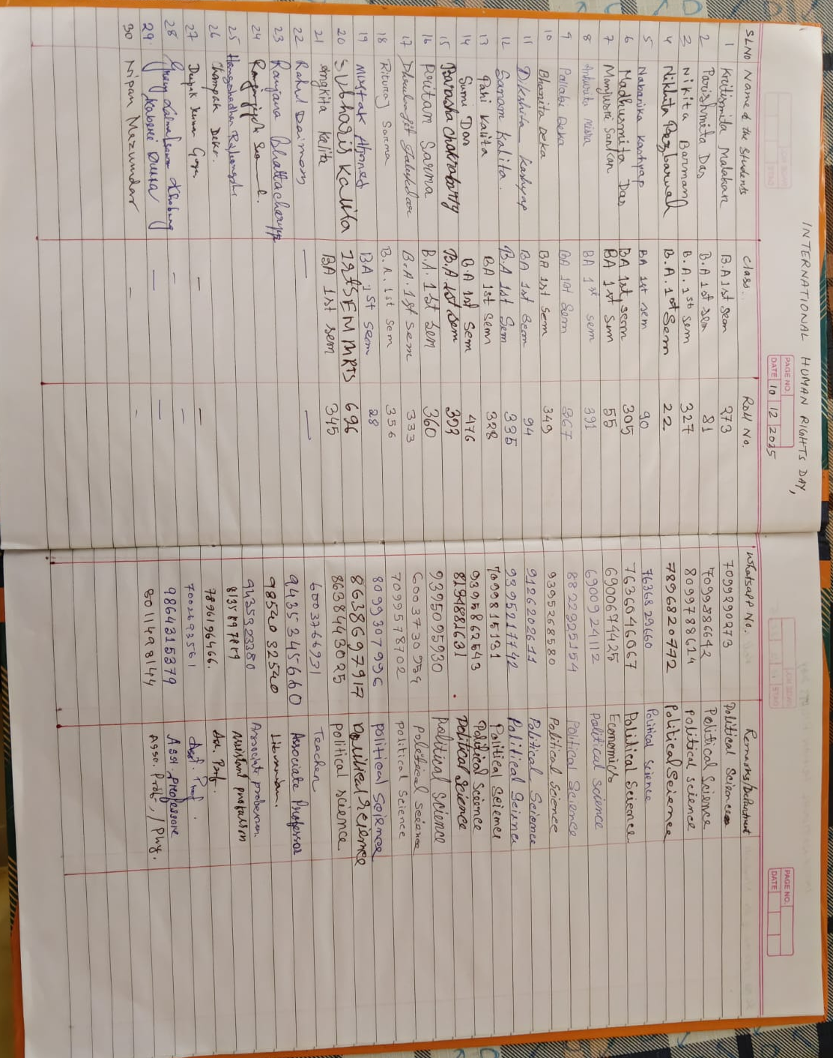

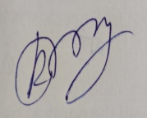

Sign of HOD
Political Science
Nalbari College, Nalbari

