- Name of the Department/Center/Cell/Committee: Political Science

- Title of the event: Extension Activity of the Department

- Venue: PM SHRI Ananda Ram Baruah H.S. School, Marowa

3. Date: 29-05-2026

- Organized by: Department of Political Science in association with Department of History and IQAC, Nalbari College.

- Programme Coordinator(s): Prof. Sachindra Kumar Kalita and Dr. Rahul Daimary

- Name of the Resource Person: Prof. Sachindra Kumar Kalita and Dr. Rahul Daimary

No. of Participants: 123

- Nature of Participation: Students of Class-IX and Class-X

- Activities Carried out/Description of the event: (A Short Paragraph should be written about the event): The faculty member of Deptt. of Political Science and History, Nalbari College, Nalbari visited the PM SHRI Ananda Ram Baruah H.S School, Morowa as a part of the extension activities of the College. The faculty members of the team delivered counseling lectures to the students in presence of the Principal and other teaching staffs of the School. Large numbers of students particularly of class IX and X were attended the counseling programme. The students were seen very attentive and responsive during the interactive session with the resource persons.

- Event Photographs:

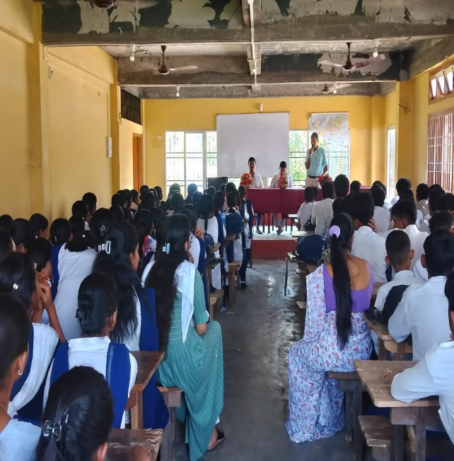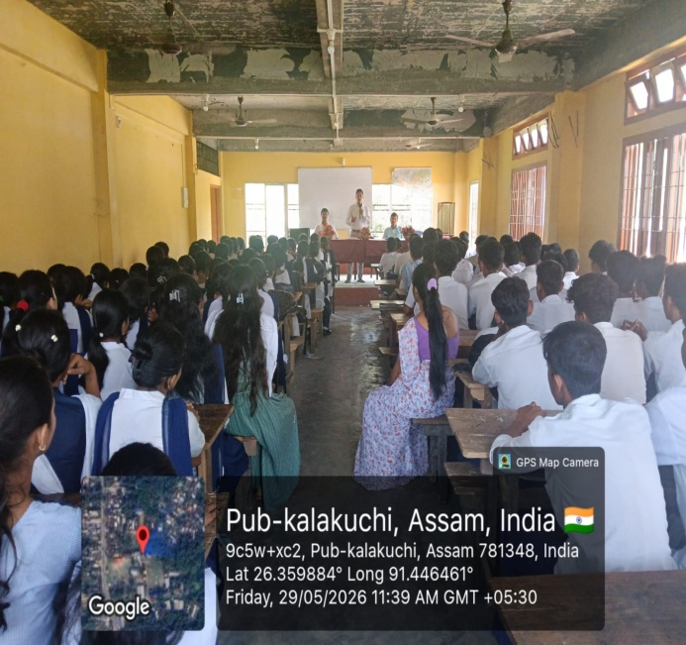

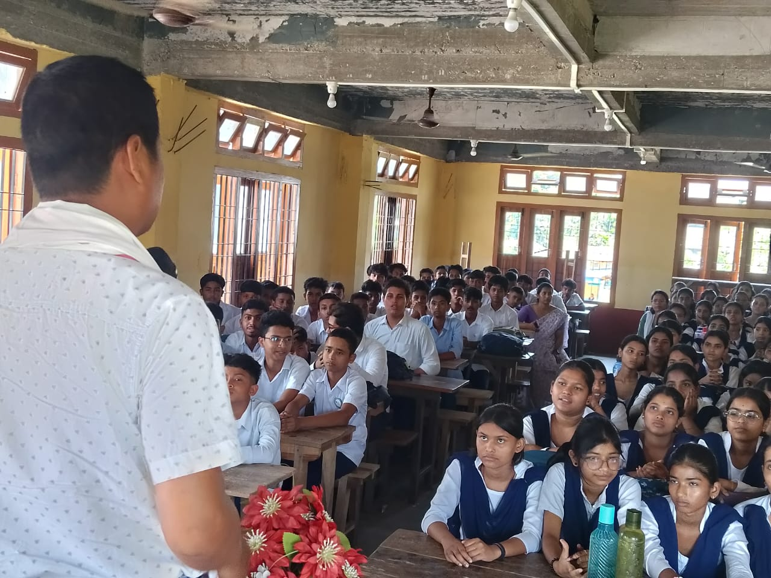

- Signature of Participants:

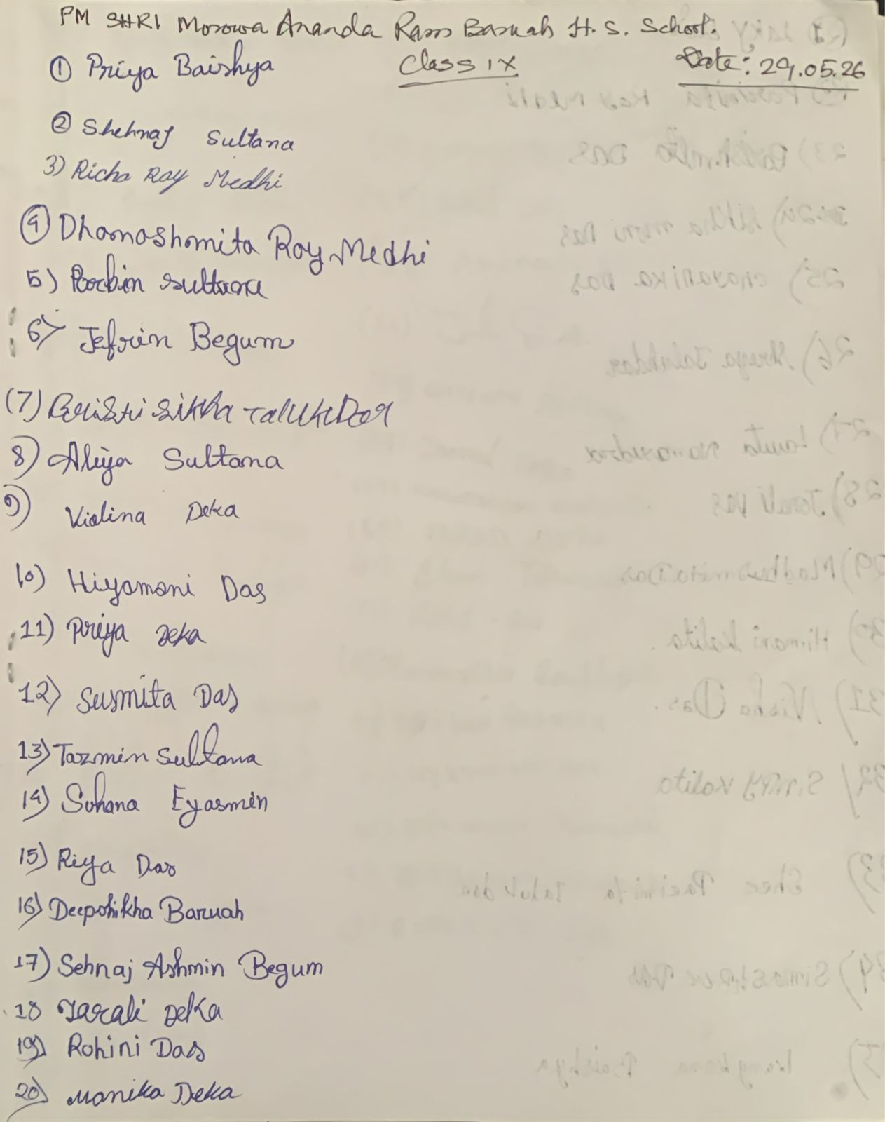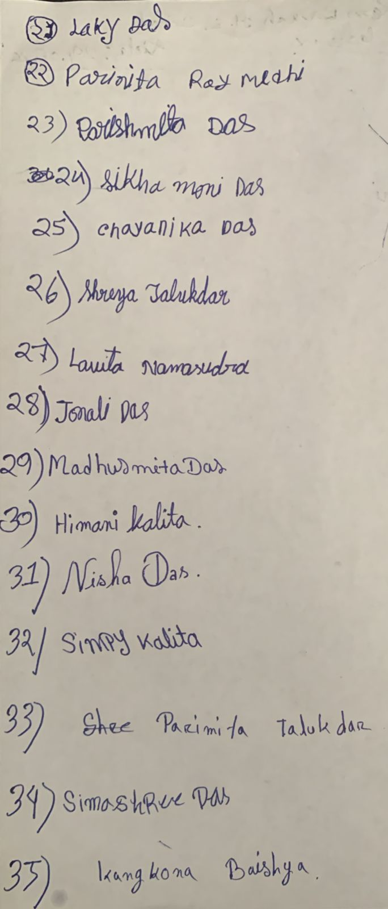

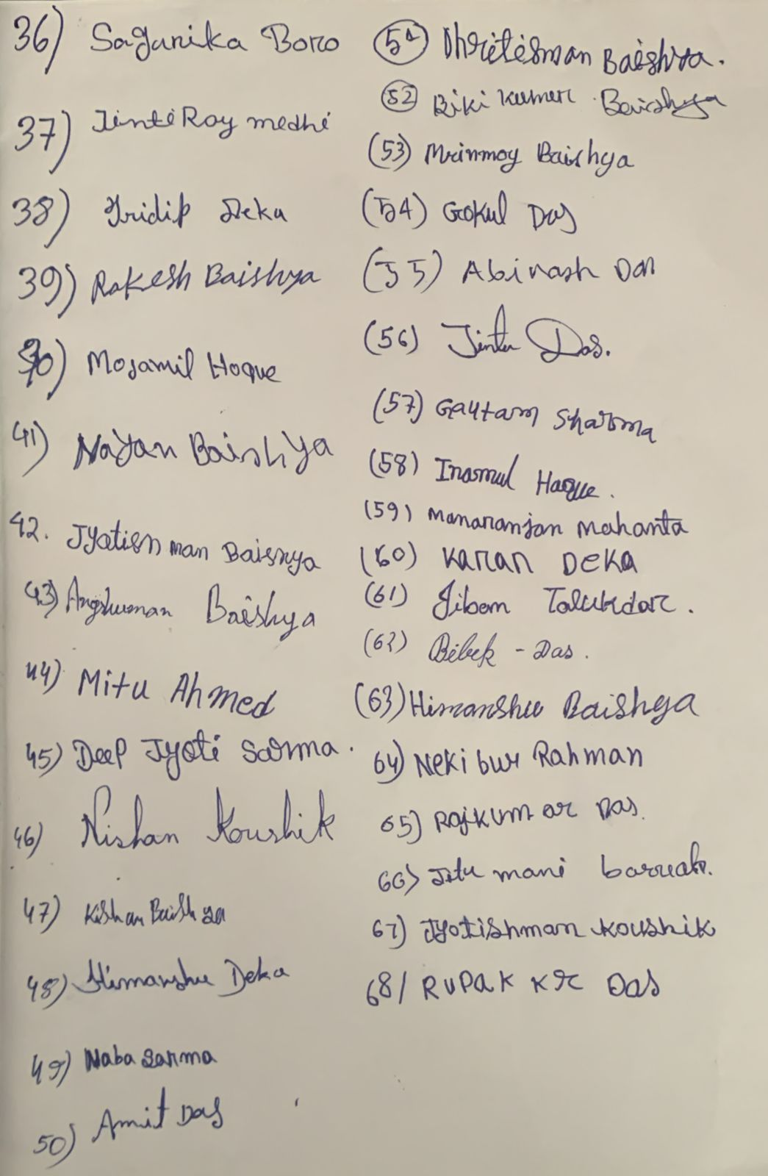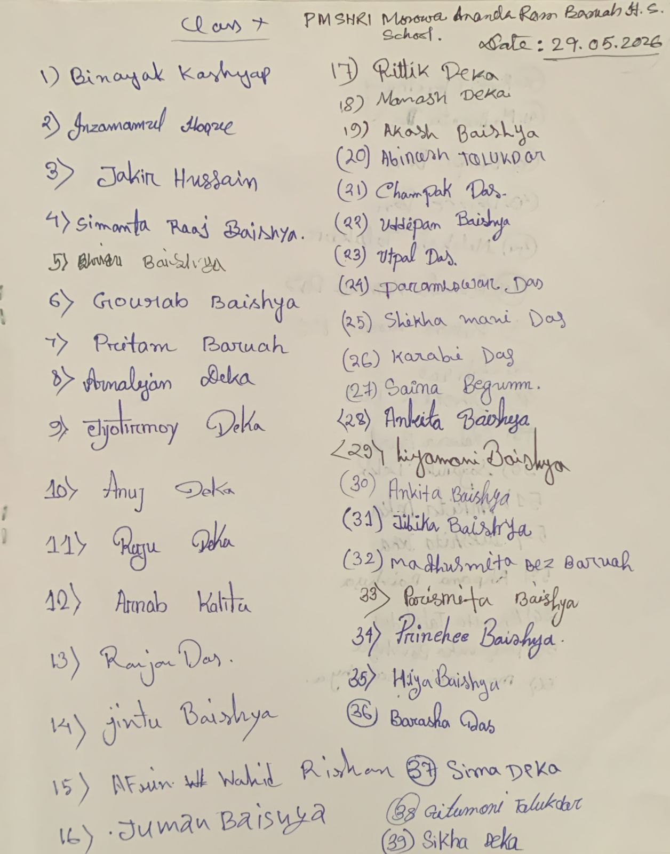

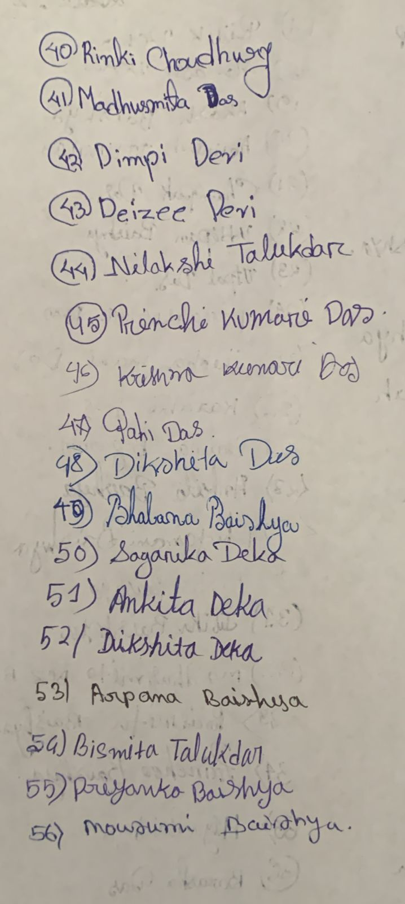

HoD
Political Science

