- Name of the Department/Center/Cell/Committee: Political Science

- Title of the event: One Day Speech Competition under Youth Parliament

- Venue: Nalbari College, Nalbari (Digital Class Room)

3. Date: 25/06/2026

- Organized by: Inspector of Schools and Department of Political Science

- Programme Coordinator(s): Dr. Rahul Daimary and Binita Rajbongshi
- Name of the Resource Person:

No. of Participants: 22

- Nature of Participation: Students and Teaching Faculty

- Activities Carried out/Description of the event: (A Short Paragraph should be written about the event)

Inspector of Schools, Nalbari in collaboration with the Department of Political Science, Nalbari College, Nalbari organized ‘One Day Speech Competition under Youth Parliament’ on the theme “The Impact of Social Media on Students’ Education and Well-being” on 25/6/26 at Nalbari College, Nalbari. The session was led by the appointed speaker Dr. Darshana Goswami and two judges Dr. Binoy Musahary and Mr. Jitumani Deka. A few numbers of students from various institutions participated the speech competition. Among the participants Anupam Goswami, class XII of Nalbari College secured 1st prize and Hrishikesh Talukdar, Class XII of RNC. HS School secured 2nd prize.

- Event Photographs:

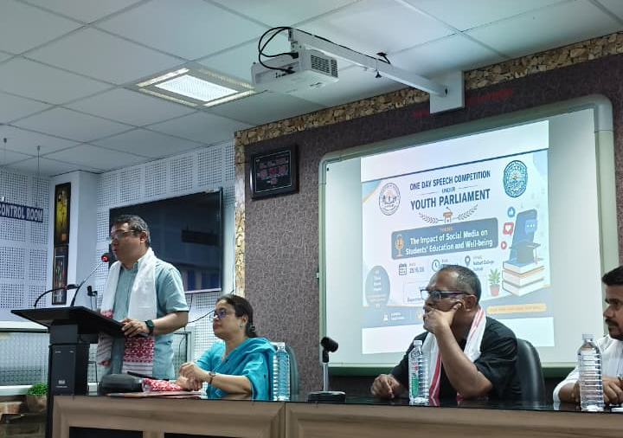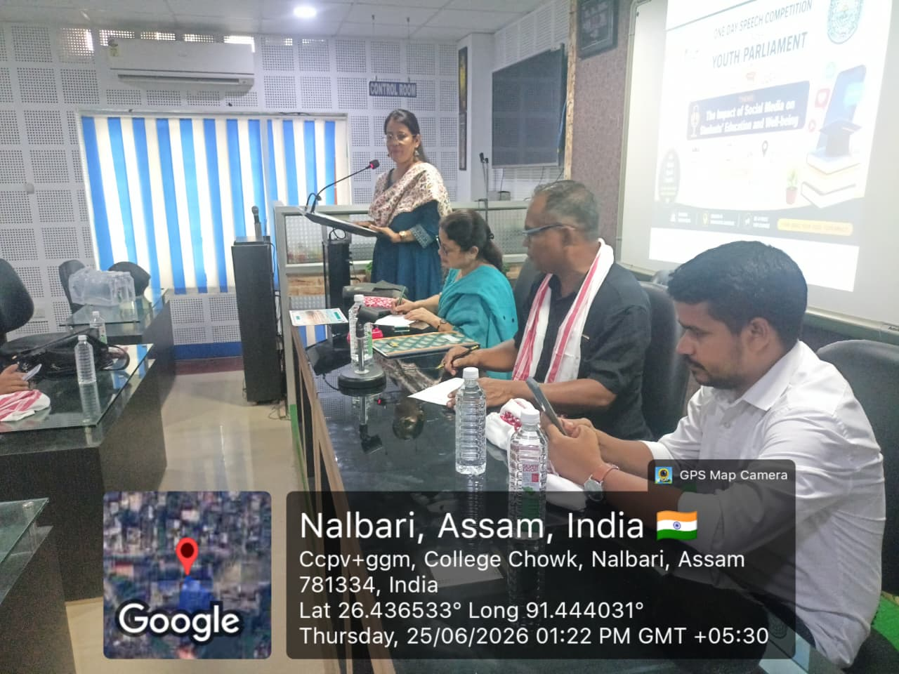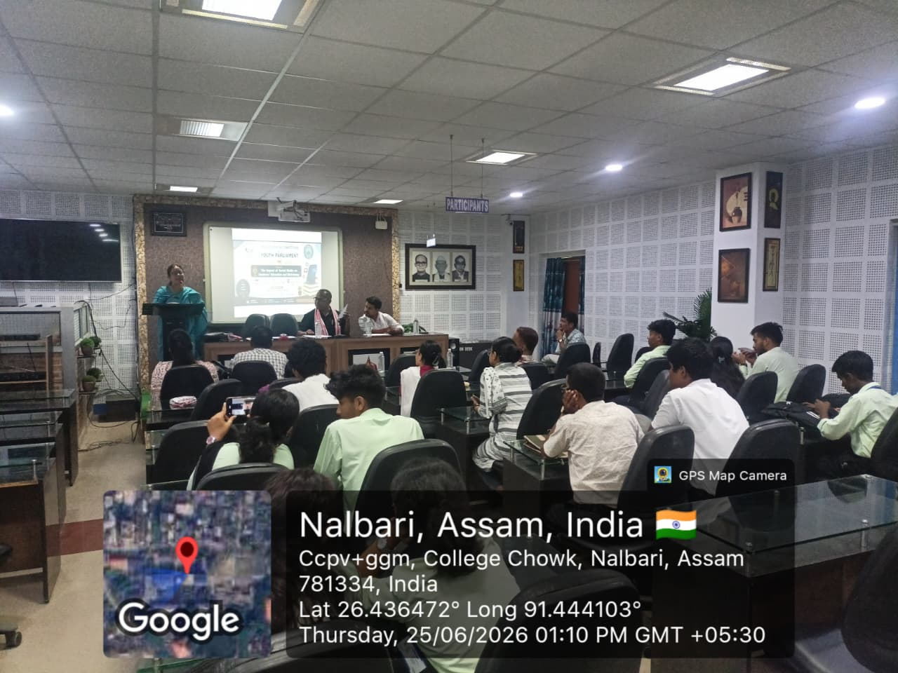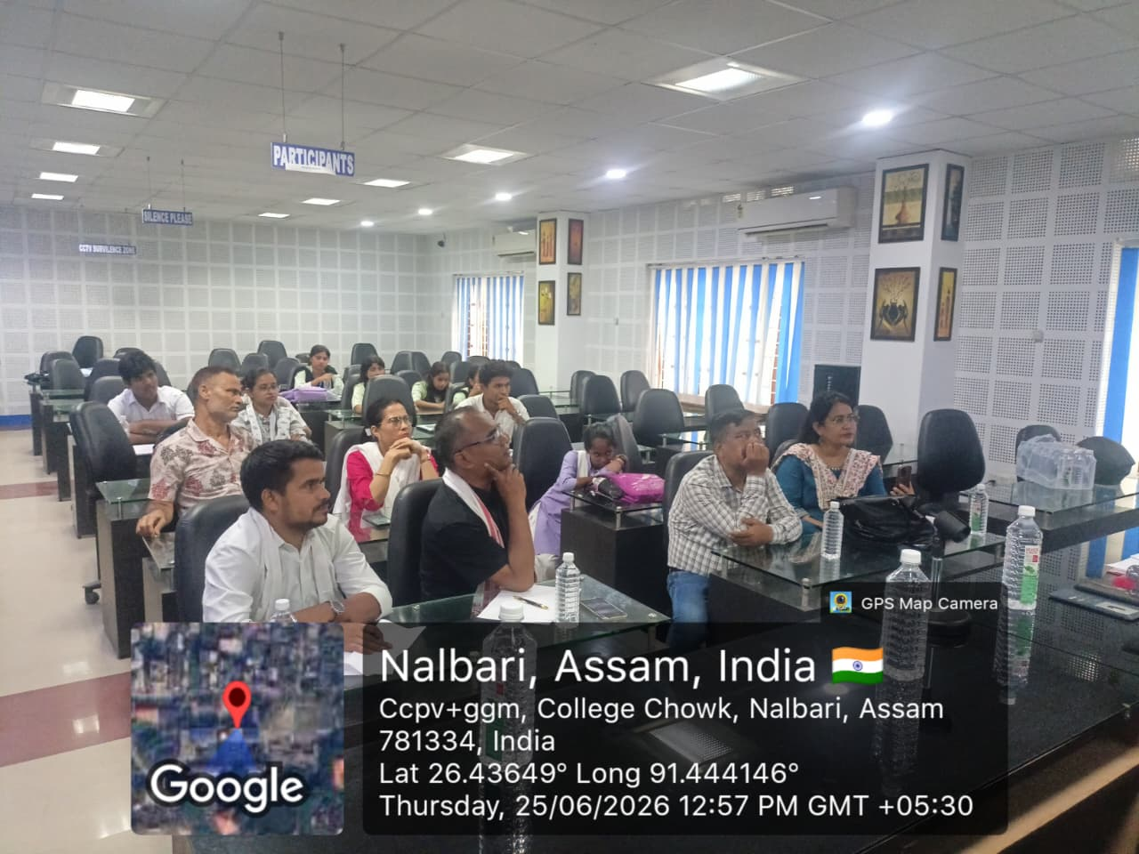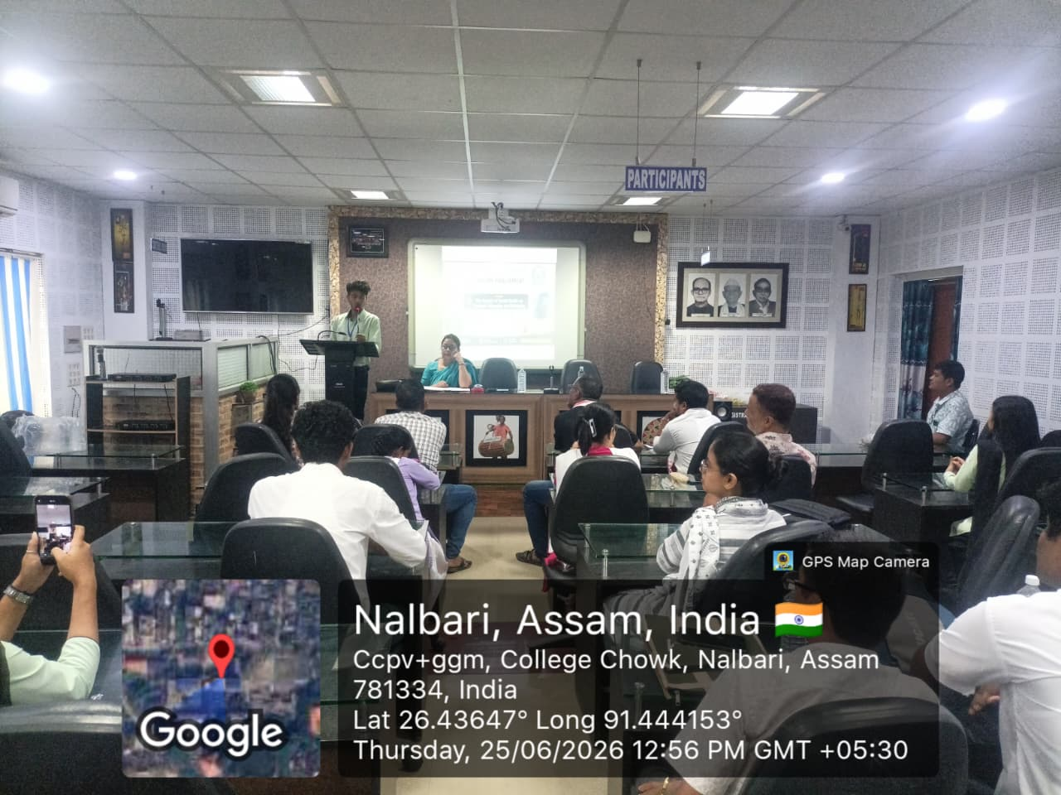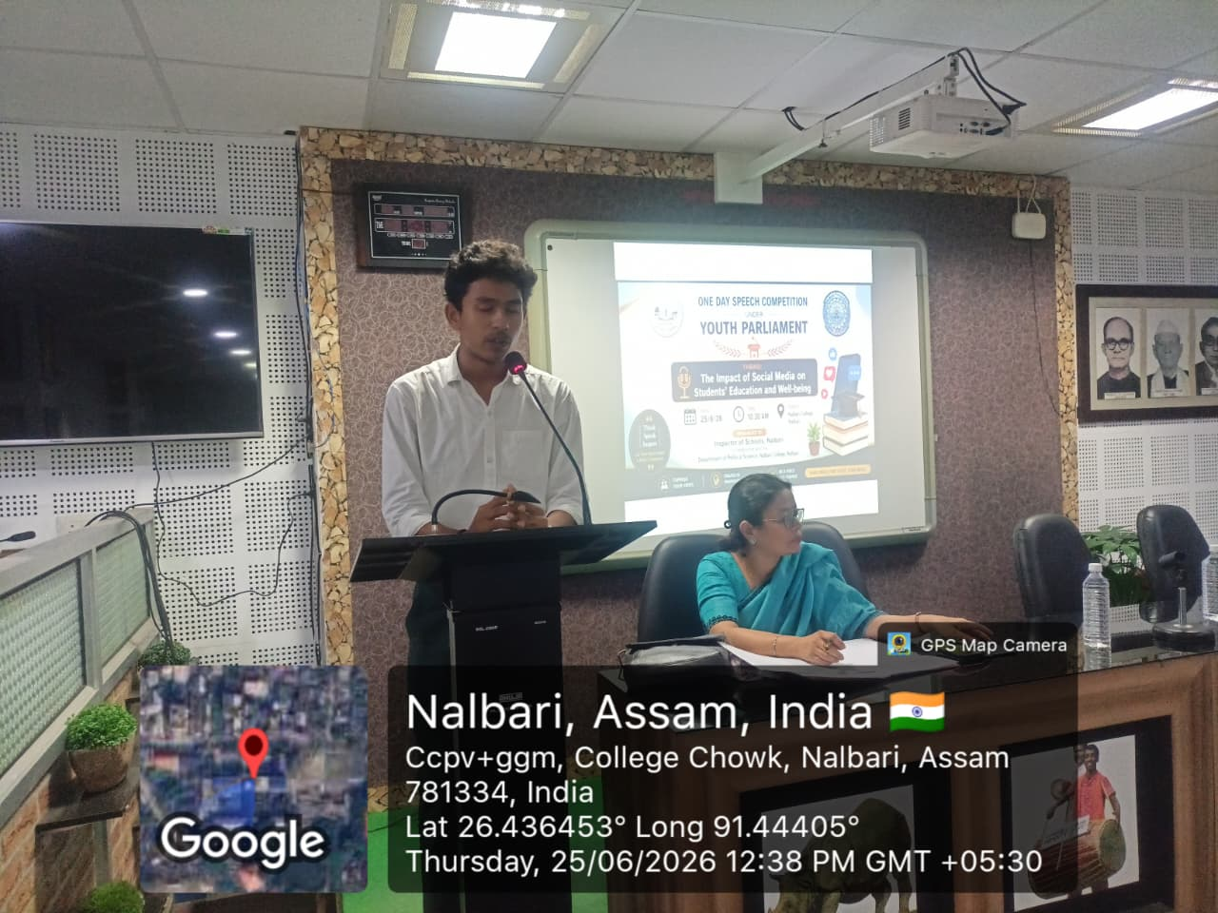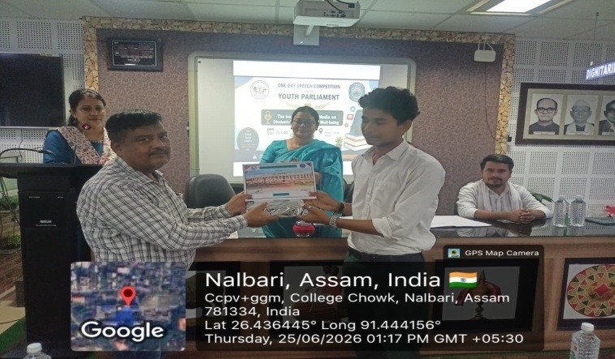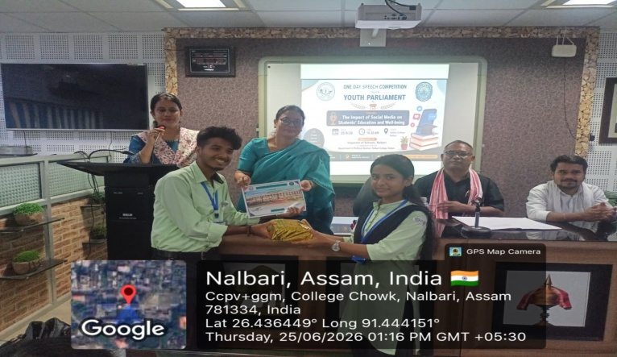

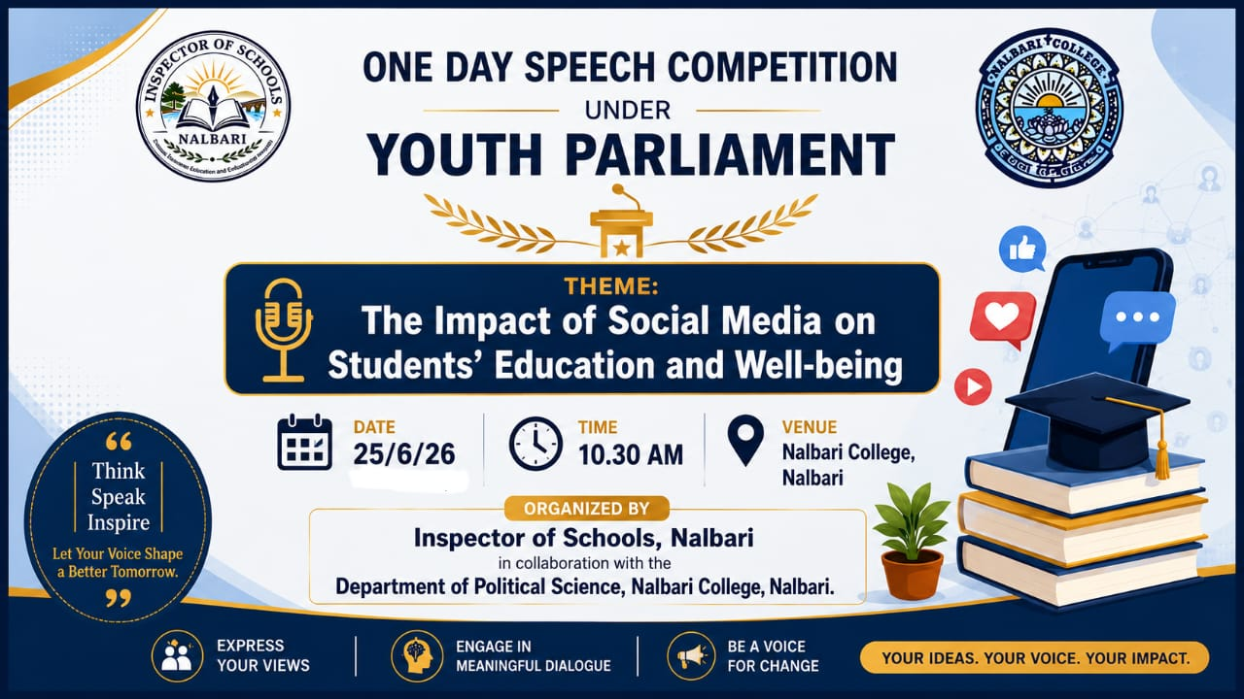

- Signature of Students:

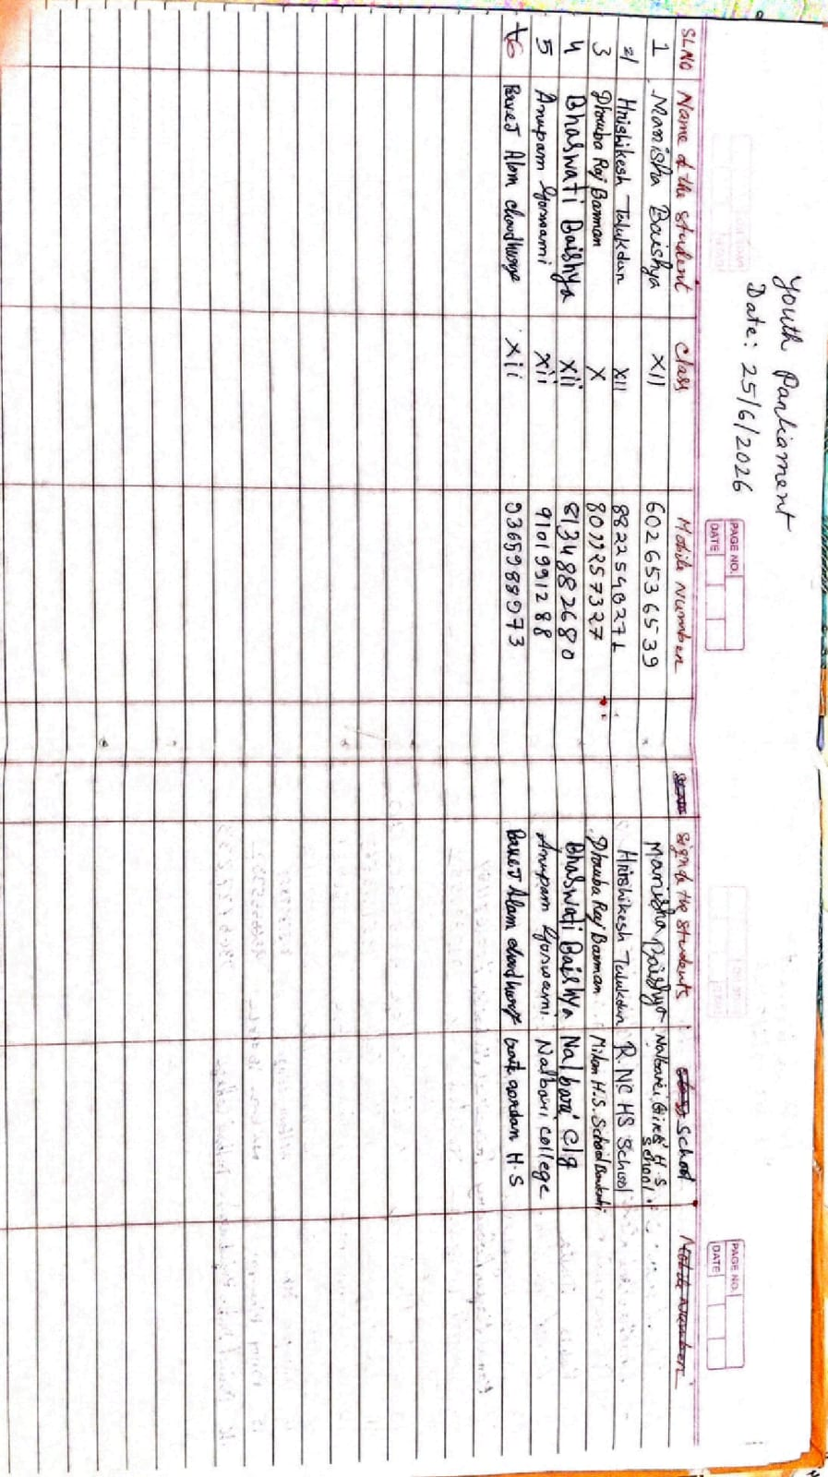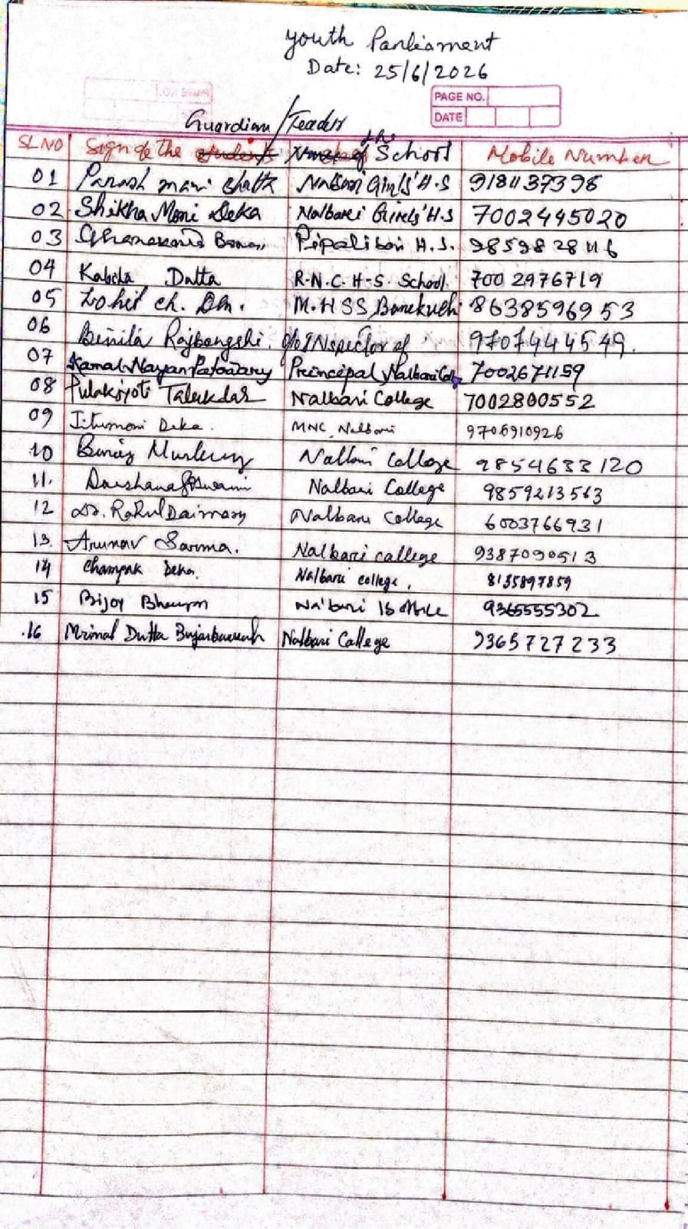

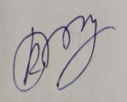

HOD
Political Science
Nalbari College, Nalbari

