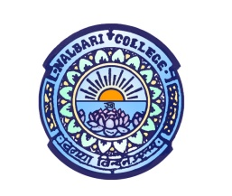 | DEPARTMENT OF CHEMISTRY  NALBARI COLLEGE  NALBARI – 781335  ASSAM
Dr.Dhiraj Talukdar  Associate Professor & Head |  |  | Contact No.  70021 14569
Ref. No.: |  |  |  | Date: 12/02/2024

Notice
It is for the information of the students of B Sc 6th semester, Chemistry (Honours) that for the Paper CHE-HE-6056 (Dissertation), they will have to do research work. The research work will have to be performed as per the following arrangement:
Sl no. | Students Name | Supervisor Name
1 | Pareeza Ahmed | Dr. Dhiraj Talukdar
2 | Anjan Bharali | Dr. Dhiraj Talukdar
3 | Barbie Barman | Dr. Dhiraj Talukdar
4 | Jumi Kalita | Dr. Nabajyoti Deka
5 | Karina Kalita | Dr. Nabajyoti Deka
6 | Kankana Sarma | Dr. Nabajyoti Deka
7 | Manabendra Das | Dr. Dhanju Mani Pathak
8 | Urnisha Deka | Dr. Dhanju Mani Pathak
9 | Daijee Baishya | Dr. Dhanju Mani Pathak
10 | Arnabjan Talukdar | Dr. Rupam Sarma
11 | Sehnaj Parbin Choudhury | Dr. Rupam Sarma
12 | Jyotishman Kalita | Dr. Rupam Sarma
13 | Daisy Haloi | Dr. Purabi Sarmah
14 | Jubi Medhi | Dr. Purabi Sarmah
15 | Bhargab Parashar | Dr. Purabi Sarmah
16 | Surajit Barman | Dr. Pranita Bora
17 | Asifuddin Ahmed | Dr. Pranita Bora
18 | Uddipta Deka | Dr. Pranita Bora

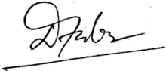
(Dr. Dhiraj Talukdar)

